11.64: a)

b)
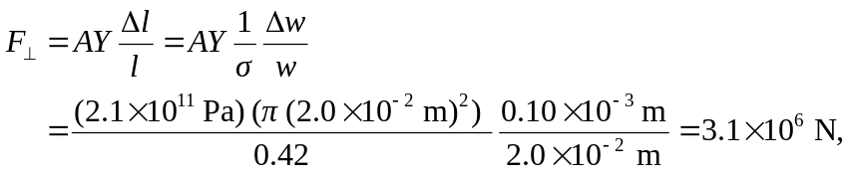

where the Young’s modulus for nickel has been used.

